Formal Languages

Chomsky Hierarchy
Noam Chomsky categorized regular and other languages as follows:

Recursively enumerable (type 0)
Context sensitive grammar (type 1)
Context free grammar (type 2)
Regular grammar (type 3)

This is a hierarchy, so every language of type 3 is also of types 2, 1 and 0; every language of type 2 is also of types 1 and 0 etc. The distinction between languages can be seen by examining the structure of the production rules of their corresponding grammar, or the nature of the automata which can be used to identify them.

Type 3:
Regular grammars. The languages defined by Type 3 grammars are accepted by finite state automata; morphological structure and perhaps all the syntax of informal spoken dialogue is describable by regular grammars. There are two kinds of regular grammar:
- Right-linear (right-regular), with rules of the form or ; the structural descriptions generated with these grammars are right-branching.
- Left-linear (left-regular), with rules of the form or ; the structural descriptions generated with these grammars are left-branching.
Type 2:
Context-free grammars. The languages defined by Type 2 grammars are accepted by push-down automata; the syntax of natural languages is definable almost entirely in terms of context-free languages and the tree structures generated by them. Type 2 grammars have rules of the form , where , . There are special `normal forms', e.g. Chomsky Normal Form or Greibach Normal Form, into which any CFG can be equivalently converted; they represent optimizations for particular types of processing.

Type 1:
Context-sensitive grammars. The languages defined by Type 1 grammars are accepted by linear bounded automata; the syntax of some natural languages (including Dutch, Swiss German and Bambara), but not all, is generally held in computational linguistics to have structures of this type. Type 1 grammars have rules of the form B where , , ,
or of the form , where is the initial symbol and is the empty string.

Type 0:

Unrestricted rewriting systems. The languages defined by Type 0 grammars are accepted by Turing machines; Chomskyan transformations are defined as Type 0 grammars. Type 0 grammars have rules of the form where and are arbitrary strings over a vocabulary V and .

Finite Automata

Deterministic Finite Automata

Developed by Robin and Scott in 1950 as a model of computer with limited memory

It can be represented as M = (Q, Σ, δ, q_{0,} F)
where Q – set of states
Σ - i/p alphabet
⎡ - stack alphabet
δ - Q x Σ Q
q₀ – initial state
F – set of final states

Exercises

L = (a^{n}b : n 0}

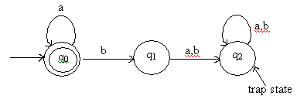

Strings defined on {0,1}, except those containing substring 001

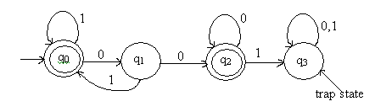

L = { awa : w{a,b}*}

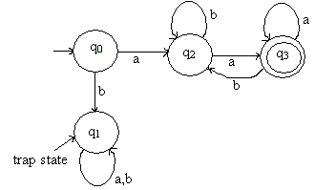

L = {aw₁aaw₂a : w₁w₂ {a,b}*}

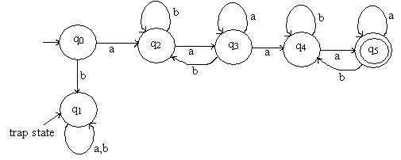
Non Deterministic Finite Automata

- Transition Function defined as δ = Q x (∑ x {}) 2^{Q}
- There can be undefined transitions.
- There can be more than one transition for a specific case

Exercises

L = {a³} {a^{2n}}

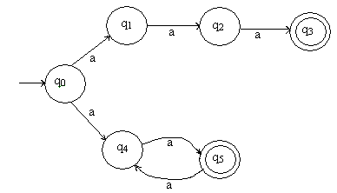

Strings defined on {0,1} ending with 11.

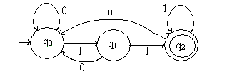

Strings defined on {a,b} containing substring aabb

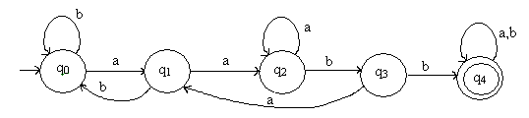

Strings defined on {0,1}, except those containing two consecutive zero’s or one’s

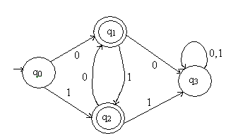

NFA without transitions

For the figure given below, check whether input 011 is accepted or not

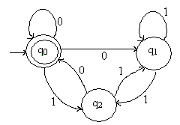

State | Input
 | 0 | 1
q₀ | { q₀, q₁} | {q₂}
q₁ | φ | { q₁, q₂}
q₂ | { q₀,q₂} | { q₁}

δ( q₀,0) = { q₀, q₁}

δ*( q₀,01) = δ( δ( q₀,0),1)

= δ( { q₀, q₁},1)

= δ( q₀,1) δ( q₁,1)

= { q₂} { q₁, q₂}

= { q₁, q₂}

δ*( q₀,011) = δ( δ*( q₀,01),1)

= δ( {q₁, q₂},1)

= δ( q₁,1) δ( q₂,1)

= { q₁, q₂} { q₂}

= { q₁, q₂}

But the final state from the picture is q₂ , hence ‘011’ is not accepted by the machine.

NFA with transitions

For the figure given below, check whether input ‘ab’ is accepted or not

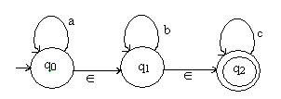

- closure (q₀) = {q₀, q₁, q₂}

// starting from q₀ which all states we can include by taking as input

δ*( q₀, ) = - closure (q₀) = {q₀, q₁, q₂}

δ*( q₀, a) = - closure (δ(δ*( q₀, )), a)

= - closure (δ({q₀, q₁, q₂}), a)

= - closure (δ( q₀,a), δ( q₁,a), δ( q₂,a) )

= - closure ({q₀}, φ, φ)

= - closure ({q₀})

= {q₀, q₁, q₂}

δ*( q₀, ab) = - closure (δ(δ*( q₀, a)), b)

= - closure (δ( q₀,b), δ( q₁,b), δ( q₂,b) )

= - closure (φ, {q₁}, φ)

= - closure (q₁)

= { q₁, q₂}

q₂ is the final state , hence ‘ab’ is accepted by the machine.

Equivalence between NFA and DFA

We are going to prove that the DFA obtained from NFA by the conversion algorithm accepts the same language as the NFA. NFA that recognizes a language L is denoted by M₁ = < Q₁ , , q_{1,0} , ₁ , A₁ > and DFA obtained by the conversion is denoted by M₂ = < Q₂, , q_{2,0} , ₂ , A₂ >

First we are going to prove by induction on strings that ₁*( q_{1,0} , w ) = ₂*( q_{2,0} , w ) for any string w. When it is proven, it obviously implies that NFA M₁ and DFA M₂ accept the same strings.
Theorem: For any string w, ₁*( q_{1,0} , w ) = ₂*( q_{2,0} , w ) .
Proof: This is going to be proven by induction on w.

Basis Step: For w = ,
₂*( q_{2,0} , ) = q_{2,0} by the definition of ₂* .
= { q_{1,0} } by the construction of DFA M₂ .
= ₁*( q_{1,0} , ) by the definition of ₁* .
Inductive Step: Assume that ₁*( q_{1,0} , w ) = ₂*( q_{2,0} , w ) for an arbitrary string w. ---

Induction Hypothesis
For the string w and an arbitrry symbol a in ,
₁*( q_{1,0} , wa ) = 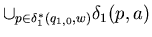
= ₂( ₁*( q_{1,0} , w ) , a )
= ₂( ₂*( q_{2,0} , w ) , a )
= ₂*( q_{2,0} , wa )
Thus for any string w ₁*( q_{1,0} , w ) = ₂*( q_{2,0} , w ) holds.

Conversion of NFA to DFA

Steps

Create vertex {q₀} where q₀ is the start state of the given NFA. Add this to set g_{D}

Repeat the following steps until no more edges are missing

Take {q_{i,} q_{j,..,} q_{k}} of g_{D} that has no transition for a∑

Compute δ*( q_{i}, a), δ*( q_{j}, a), …. , δ*( q_{k}, a)

Union δ* to {q_{l,} q_{m,..,} q_{n}}

Create vertex {q_{l,} q_{m,..,} q_{n}} if doesn’t exist

Add to g_{D} to an edge from {q_{i,} q_{j,..,} q_{k}} to {q_{l,} q_{m,..,} q_{n}} with label a.

Every state of g_{D} with q_{f} F is a final state.

Machine accepts if q₀ is a final state.

Exercises

Draw the equivalent DFA for the NFA’s given below.

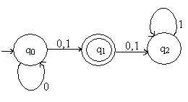

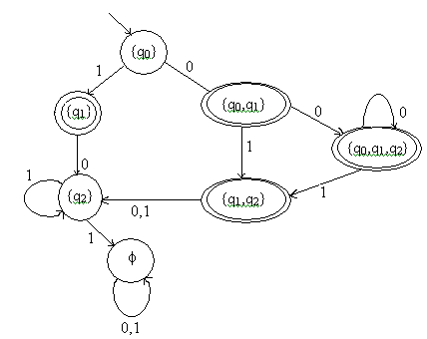

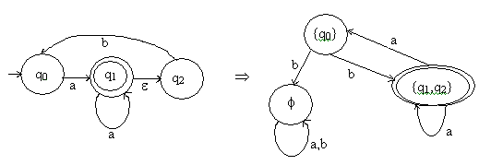

Reduction of states in finite automata

Steps

Remove all inaccessible states by traversing simples path in the graph

Consider (p,q) , if p F and qF or vice versa those states are considered as distinguishable

Repeat the following

i. For all pairs (p,q) and a∑, compute δ( p,a) = p_{a} and δ(q,a) = q_{a}. If (p_{a}, q_{a}) is distinguishable (p,q) is also distinguishable.

Exercises

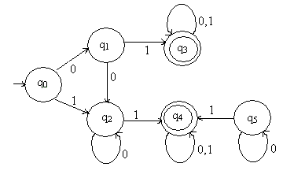

Set 1 Set 2

{q₀, q₁, q₂} {q₃, q₄}

(q₀, q₁)

δ(q₀, 0) = q₁

δ(q₁, 0) = q₂

δ(q₀, 1) = q₂

δ(q₁, 1) = q₃

Since q₃ is a final state and q₂ is a non final state, (q₀, q₁) is distinguishable for input 1

(q₀, q₂)

δ(q₀, 0) = q₁

δ(q₂, 0) = q₂

δ(q₀, 1) = q₂

δ(q₂, 1) = q₄

Since q₄is a final state and q₁is a non final state, (q₀, q₂) is distinguishable for input 1

(q₁, q₂)

δ(q₁, 0) = q₂

δ(q₂, 0) = q₂

δ(q₁, 1) = q₃

δ(q₂, 1) = q₄

Since (q₁, q₂) fail for both inputs (q₁, q₂ ) is Indistinguishable.

(q₃, q₄)

δ(q₃, 0) = q₃

δ(q₄, 0) = q₄

δ(q₃, 1) = q₃

δ(q₄, 1) = q₄

Since (q₃, q₄) fail for both inputs (q₃, q₄) is Indistinguishable.

Distinguishable = { q₀}

Indistinguishable = {q₁, q₂} , { q₃, q₄}

DFA after reduction is

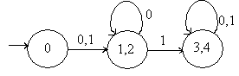

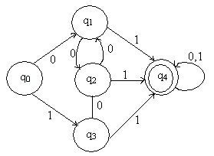

Set 1 Set 2

{q₀, q₁, q₂, q₃} {q₄}

(q₀, q₁)

δ(q₀, 0) = q₁

δ(q₁, 0) = q₂

δ(q₀, 1) = q₃

δ(q₁, 1) = q₄

Since q₄ is a final state and q₃ is a non final state, (q₀, q₁) is distinguishable for input 1

(q₀, q₂)

δ(q₀, 0) = q₁

δ(q₂, 0) = q₂

δ(q₀, 1) = q₃

δ(q₂, 1) = q₄

Since q₄ is a final state and q₃ is a non final state, (q₀, q₂) is distinguishable for input 1

(q₀, q₃)

δ(q₀, 0) = q₁

δ(q₃, 0) = q₂

δ(q₀, 1) = q₃

δ(q₃, 1) = q₄

Since q₄ is a final state and q₃ is a non final state, (q₀, q₃) is distinguishable for input 1

(q₁, q₂)

δ(q₁, 0) = q₂

δ(q₂, 0) = q₁

δ(q₁, 1) = q₄

δ(q₂, 1) = q₄

Since (q₁, q₂) fail for both inputs (q₁, q₁) is Indistinguishable.

(q₂, q₃)

δ(q₂, 0) = q₁

δ(q₃, 0) = q₂

δ(q₂, 1) = q₄

δ(q₃, 1) = q₄

Since (q₂, q₃) fail for both inputs (q₂, q₃) is Indistinguishable

(q₁, q₃)

δ(q₁, 0) = q₂

δ(q₃, 0) = q₂

δ(q₁, 1) = q₄

δ(q₃, 1) = q₄

Since (q₁, q₃) fail for both inputs (q₁, q₃) is Indistinguishable

Distinguishable = {q₀}, {q₄}

Indistinguishable = {q₁, q₂ , q₃ }

DFA after reduction is

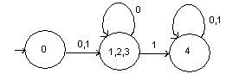

Finite Automata with output

Moore machine
A finite state machine that produces an output for each state. Output depends on present state, it is independent of current input. It can be represented as
M = (Q, Σ, Δ, δ, λ, q₀)
where Δ - output alphabet

λ - mapping function from Q to Δ

Figure below shows Moore machine when given ‘bababbb’ as input producing ‘01100100’ as output.
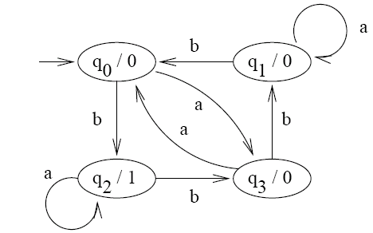

Mealy machine
A finite state machine which produces an output for each transition. Output depends on present state and current input. It can be represented as
M = (Q, Σ, Δ, δ, λ, q₀)
where Δ - output alphabet

λ - mapping function from Q x Σ to Δ

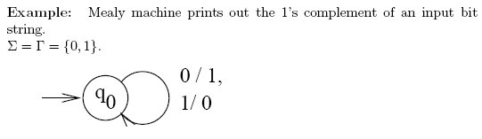

Converting Mealy machine to Moore machine

Exercises

Convert the following mealy machine two equivalent moore machine

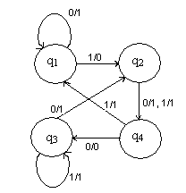

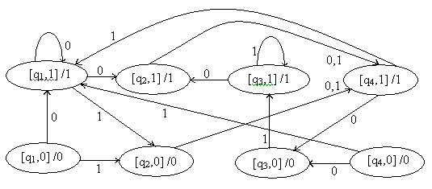

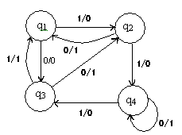

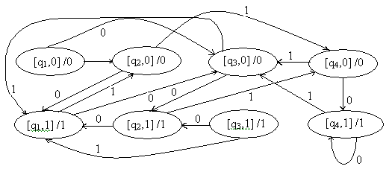

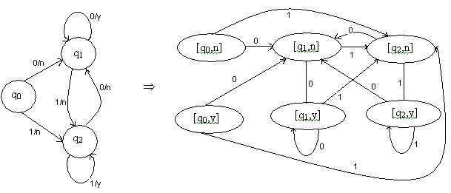

Two way Finite Automata

A finite state machine which can move its head in both direction. It can be represented as
M = (Q, Σ, δ, q₀ ,F)
where δ - mapping function from Q x Σ to Q x {L,R}

Exercise
Consider a two way finite machine with final state q₁ and transitions as given below. Check the acceptance of input sequence 101001

 | 0 | 1
q₀ | (q₀,R) | (q₁,R)
q₁ | (q₁,R) | (q₂,L)
q₂ | (q₀,R) | (q₂,L)

q₀101001 1q₁01001 10q₁1001 1q₂01001 10q₀1001 101q₁001

1010q₁01 10100 q₁1 1010q₂01 10100q₀1 101001q₁

Since final state reached is q₁, the input is accepted by the machine.

Regular Expressions

A regular expression is a formula for matching strings that follow some pattern.

Pumping lemma for regular expressions
As per Pigeonhole principle, if there are n objects and m boxes, one box have more than one object. Pumping lemma is based on this principle. It states that
- If an infinite language is regular, it can be defined by a dfa.
- The dfa has some finite number of states (say, n).
- Since the language is infinite, some strings of the language must have length > n.
- For a string of length > n accepted by the dfa, the walk through the dfa must contain a cycle.
- Repeating the cycle an arbitrary number of times must yield another string accepted by the dfa.
The pumping lemma for regular languages is a way of proving that a given (infinite) language is not regular. It can be briefed as below.
- Assume the language L is regular.
- By the pigeonhole principle, any sufficiently long string in L must repeat some state in the dfa; thus, the walk contains a cycle.
- Show that repeating the cycle some number of times ("pumping" the cycle) yields a string that is not in L.
- Conclude that L is not regular.
If L is an infinite regular language, then there exists some positive integer m such that any string w L whose length is m or greater can be decomposed into three parts, xyz, where
- |xy| is less than or equal to m,
- |y| > 0,
- w_{i} = xy^{i}z is also in L for all i = 0, 1, 2, 3, ....
It means that
- m is a (finite) number chosen so that strings of length m or greater must contain a cycle. Hence, m must be equal to or greater than the number of states in the dfa. Remember that we don't know the dfa, so we can't actually choose m; we just know that such an m must exist.
- Since string w has length greater than or equal to m, we can break it into two parts, xy and z, such that xy must contain a cycle. We don't know the dfa, so we don't know exactly where to make this break, but we know that |xy| can be less than or equal to m.
- We let x be the part before the cycle, y be the cycle, and z the part after the cycle. (It is possible that x and z contain cycles, but we don't care about that.) Again, we don't know exactly where to make this break.
- Since y is the cycle we are interested in, we must have |y| > 0, otherwise it isn't a cycle.
- By repeating y an arbitrary number of times, xy*z, we must get other strings in L.
- If, despite all the above uncertainties, we can show that the dfa has to accept some string that we know is not in the language, then we can conclude that the language is not regular.
Normal Forms

Chomsky Normal Form
A grammar is in Chomsky Normal Form if all productions are of the form
ABC | a
where a T and B,C V* and there is no unit production.

Greibach Normal Form

A grammar is in Greibach Normal Form if all productions are of the form
Aax
where a T and x V*.
To reduce a grammar into GNF form, the following actions have to be performed.
Construct a grammar CFG, G in CNF generating the CFL L. Rename the variables in V as {A₁ A2 .. A_{n} } with start symbol as A_{1.}

Step 1

Modify the productions, such that A_{i} A_{j} γ where i < j.

Step 2
If A_{k} A_{j} γ is a production with j < k, generate a new set of productions by substituting for A_{j ,} the right hand side of the A_{j} production. By repeating this we obtain the production of the form A_{k} A_{l} γ, kl. The production with l = k are replaced by introducing new variable. By repeating the above steps for each variable we obtain the required form.

Eg.
S aSb | bSa | a | b

Modifying the grammar into CNF form
S D_{a}SD_{b} | D_{b}SD_{a} | a | b
D_{a} a
D_{b} b

Rename variables S , D_{a ,} D_{b} as A_{1,} A2, A_{3.}
A₁ A₂ A₁A₃| A₃ A₁ A₂
A₁ a
A₂ a
A₃ b

All the A₁ productions are of the form A_{i} A_{j} i < j
A₁ A₂ A₁A₃| A₃ A₁ A₂
Convert this productions of the form
A_{i} aα where a T and A V* and substititute for left most variables, we will get the required form

A₂ a A₃ b
A₁ A₂ A₁A₃ A₁ A₃ A₁ A₂
⇒ a A₁A₃ A_{1⇒} b A₁ A₂
The resulting grammar in GNF is
A₁ aA₁A₃ | b A₁ A₂ | a | b
A₂ a
A₃ b

Pushdown Automata (NPDA)

Pushdown Automatas are finite automatons with a stack. The languages which can be recognized by PDA are precisely the context free languages. It can be represented as
M = (Q, Σ, ⎡, δ, q_{0,} z, F)
where Q – set of states
Σ - i/p alphabet
⎡ - stack alphabet
δ - Q x (Σ ∪ {} ) x ⎡
z – start stack symbol
F – set of final states
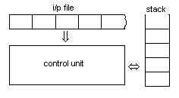
Exercises

Write down the PDA for the following languages
- L = {a^{n}b^{n} : n 0} {a}

M = {{q₀, q₁, q₂, q₃}, {a,b}, {0,1}, δ, q_{0,} z,{ q₃}}
δ(q_{0 ,} a, 0) = {(q_{0 ,} 10), (q_{3 ,} )}
δ(q_{0 ,} , 0) = (q_{3 ,} )
δ(q_{1 ,} a, 1) = (q_{1 ,} 11)
δ(q_{1 ,} b, 1) = (q_{2 ,} )
δ(q_{2 ,} b, 1) = (q_{2 ,} )
δ(q_{2 ,} , 0) = (q_{3 ,} )

- L = {w {a,b}* : n_{a}(w) = n_{b}(w)}

M = {{q₀, q_{f}}, {a,b}, {0,1,z}, δ, q_{0,} z,{q_{f} }}
δ(q_{0 ,} , z) = (q_{f ,} z)
δ(q_{0 ,} a , z) = (q _{0,} 0z)
δ(q_{0 ,} b , z) = (q_{3 ,} 1z)
δ(q_{0 ,} b , 1) = (q_{0 ,} 11)
δ(q_{0 ,} a, 0) = (q_{0 ,} 00)
δ(q_{0 ,} b, 0) = (q_{0 ,} )
δ(q_{0 ,} a, 1) = (q_{0 ,} )

- L = {ww^{R} : w {a,b}⁺ }

M = {{q₀, q_{1,} q₂}, {a,b}, {a,b,z}, δ, q_{0,} z,{q₂ }}
δ(q_{0 ,} a , a) = (q _{0,} aa)
δ(q_{0 ,} b, a) = (q_{0,} ba)
δ(q_{0 ,} a, b) = (q_{0 ,} ab)
δ(q_{0 ,} b , b) = (q_{0 ,} bb)
δ(q_{0 ,} a, z) = (q_{0 ,} az)
δ(q_{0 ,} b, z) = (q_{0 ,} bz)

δ(q_{1 ,} a, a) = (q_{1 ,} )
δ(q_{1 ,} b, b) = (q_{1 ,} )

δ(q_{1 ,} , z) = (q_{2 ,} z)

Pushdown Automata and Context free grammars

Every CFL has a equivalent NPDA.
Steps

- Convert the given CFL into GNF.
- Push the variables in the right hand side of the productions into the stack.
- Push start symbol into the stack.
- To simulate Aax, A should be the top element in the stack and a should be the current input.
- Replace A by x.

Exercises

- SaSA | a
AbB
Bb

δ(q_{0 ,} , z) = (q _{1,} Sz) // Start symbol on top of stack

δ(q_{1 ,} a, S) = {(q_{1,} SA) ,( q_{1,} )} // Other productions
δ(q_{1 ,} b, A) = (q_{1,} B)
δ(q_{1,} b , B) = (q_{1 ,} )

δ(q_{1,} , B) = (q_{2 ,} ) // Final State

- SaA
AaABC | bB | a
Bb
Cc

δ(q_{0 ,} , z) = (q _{1,} Sz)

δ(q_{1 ,} a, S) = (q_{1,} A)
δ(q_{1 ,} a, A) = {(q_{1,} ABC) ,( q_{1,} C)}
δ(q_{1 ,} b, A) = (q_{1,} B)
δ(q_{1,} b , B) = (q_{1 ,} )
δ(q_{1,} c , C) = (q_{1 ,} )

δ(q_{1,} , B) = (q_{2 ,} z)

Deterministic Pushdown Automata

- Can have dead configurations
- Can have transitions

Exercise
- L = {a^{n}b^{n} : n 0}

δ(q_{0 ,} a , 0) = (q _{0,} 10)
δ(q_{1 ,} a, 1) = (q_{1,} 11)
δ(q_{1 ,} b, 1) = (q_{2 ,} )
δ(q_{2 ,} b , 1) = (q_{2 ,} )
δ(q_{2 ,} , 0) = (q_{0 ,} )

